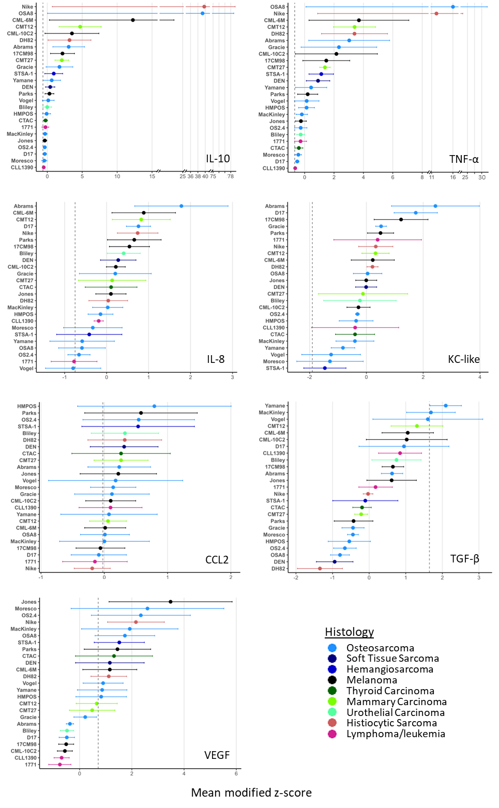
Figure 1: Modified z-scores of each analyte. Mean modified z-score for each cytokine, ranked in descending order, color-coded by histology. Vertical dotted line represents the modified z-score of control macrophages (treated with media and M-CSF only) from the same 3 donors. Data are mean +/- SEM; n=3.
Table 1. Analytes included for further analysis. Data are expressed as modified z-scores (in median absolute deviation [MAD] units). A modified z-score of +1.0 indicates the measurement lies one MAD above the median, -1.0 indicates one MAD below. Min = minimum, max = maximum.
Analyte | Median | Min | Max | Range
VEGF | 0.8998 | -0.7566 | 3.4840 | 4.2410
IL-8 | 0.1068 | -0.7979 | 1.7820 | 2.5800
KC-like | -0.0092 | -1.4630 | 2.4330 | 3.8950
IL-10 | 0.4153 | -0.5104 | 39.730 | 40.240
CCL2 | 0.1410 | -0.1905 | 0.7910 | 0.9815
TGF-β | 0.1755 | -1.3450 | 2.0940 | 3.4380
TNF-α | 0.4402 | -0.6415 | 16.020 | 16.660

Table 2: Donor-to-donor variability in modified z-scores of each cytokine. ICC (intraclass correlation coefficients) represent the fraction of total variance attributable to donor identity and the corresponding p-value from a likelihood-ratio test comparing models with and without donor as a random effect.
Cytokine | ICC | p-value
VEGF | 0.614 | <0.001
IL-8 | 0.209 | <0.001
KC-like | 0.096 | 0.055
IL-10 | 0.115 | 0.028
CCL2 | 0.754 | <0.001
TNF-α | 0.182 | 0.002
TGF-β | 0.020 | 0.604

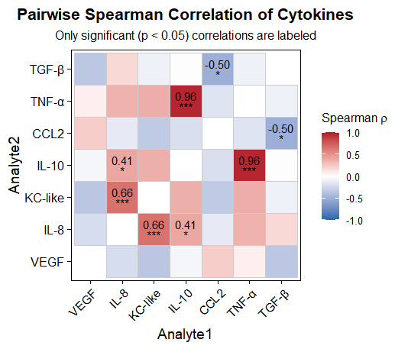
Figure 2: Spearman correlation heatmap of cytokine secretion. Each tile is colored by the Spearman ρ value (red = positive correlation, blue = negative correlation; scale bar at right). Only correlations that reached statistical significance (two‐tailed Spearman test, p < 0.05) are annotated.

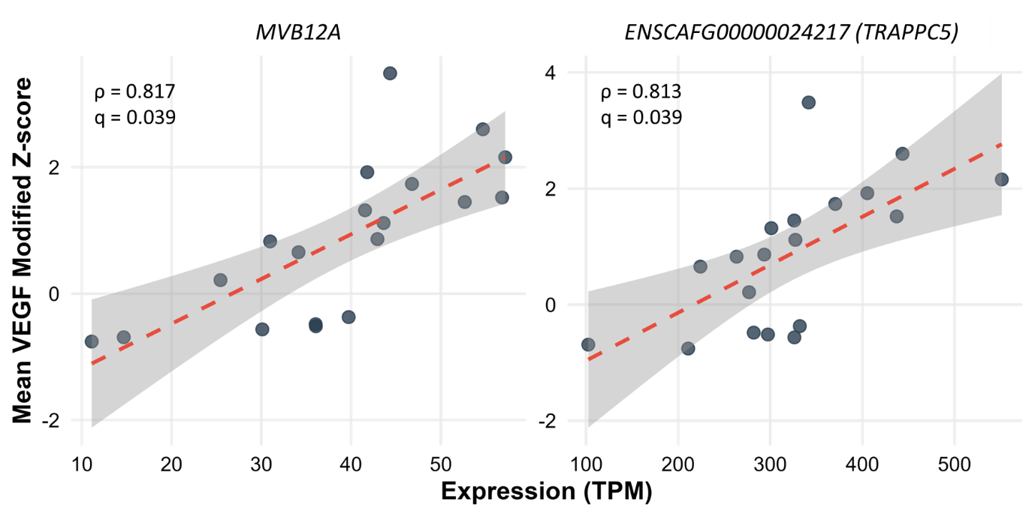
Figure 3: Spearman correlation between gene expression and VEGF response. Scatter‐plots showing the relationship between TPM‐normalized RNA-seq expression of MVB12A (left panel) and TRAPPC5 (ENSCAFG00000024217; right panel) versus mean VEGF modified Z-scores. Dashed red lines depict the linear regression trend with 95% confidence bands; annotations show each gene’s Spearman ρ and q-value.

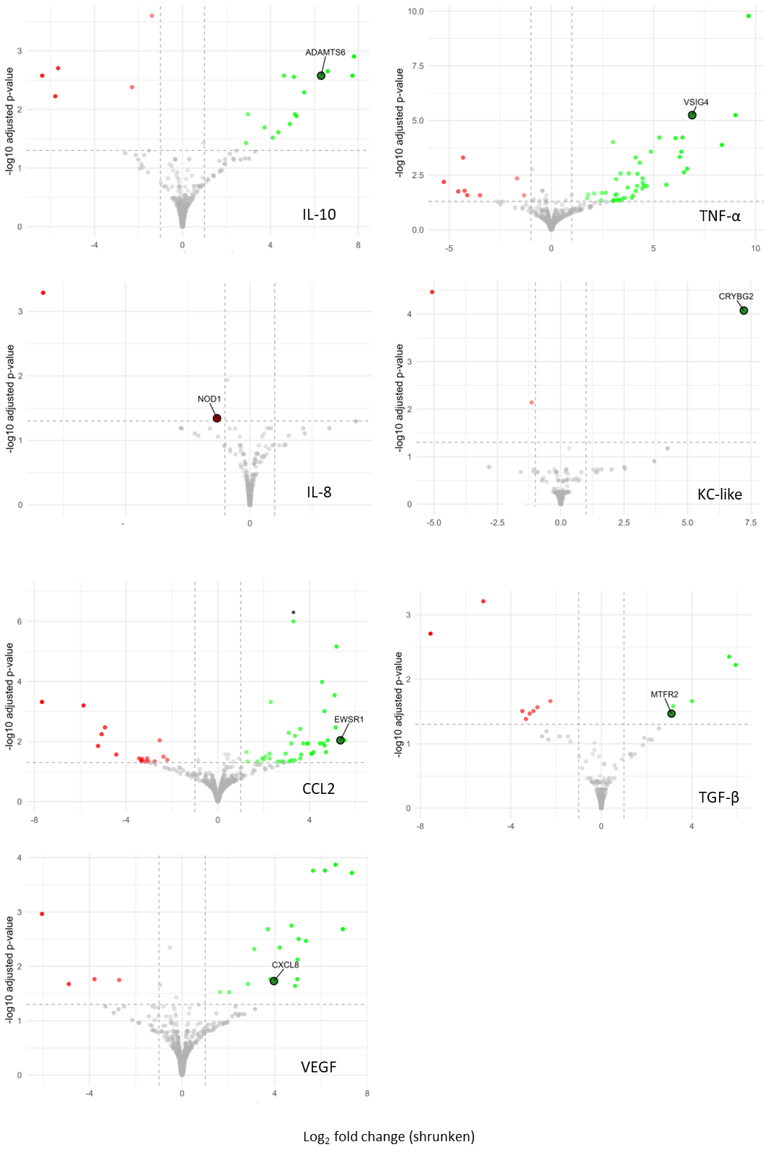
Figure 4: Volcano plots of DEGs in pairwise analysis. In each panel, the x-axis shows the shrunken log₂ fold-change and the y-axis shows –log₁₀ of the Benjamini–Hochberg–adjusted p-value. Dashed vertical lines at ±1 log₂FC and a dashed horizontal line at FDR = 0.05 indicate the significance thresholds. Genes with |shrunken log₂FC| ≥ 1 and FDR ≤ 0.05 are colored green (up-regulated) or red (down-regulated); all others are shown in gray. Asterisks mark values that exceed the plotted range (e.g. the CCL2 outlier is capped for display). Some genes of interest are highlighted in associated Table 3 (log2FC = log2FoldChange, padj = adjusted p-value).

Table 3: Select highlighted differentially expressed genes from Figure 4. FC = fold change.
Cytokine | Gene | log2FC | padj | Comment | Citation
IL-10 | ADAMTS6 | 6.308 | 2.65E-03 | Known to dismantle focal adhesions and cell-to-cell junctions | [54]
TNF- α | VSIG4 | 6.894 | 5.68E-06 | Inhibits pro-inflammatory macrophage activation | [51]
IL-8 | NOD1 | -1.321 | 4.53E-02 | Activation results in T-cell mediated anti-tumor immunity | [57]
KC-like | CRYBG2 | 7.223 | 8.45E-05 | Overexpression of similar proteins has been linked to increased cellular motility and invasiveness | [52,53]
CCL2 | EWSR1 | 5.347 | 9.09E-03 | Promotes exosome-mediated macrophage immunosuppressive polarization | [55]
TGF-β | MTFR2 | 3.1 | 3.41E-02 | Upregulation promotes tumor growth, migration and invasion, correlates with immune infiltrates | [48]
VEGF | CXCL8 | 3.967 | 1.86E-02 | TAM-derived CXCL8 promotes tumor migration and invasion | [50]

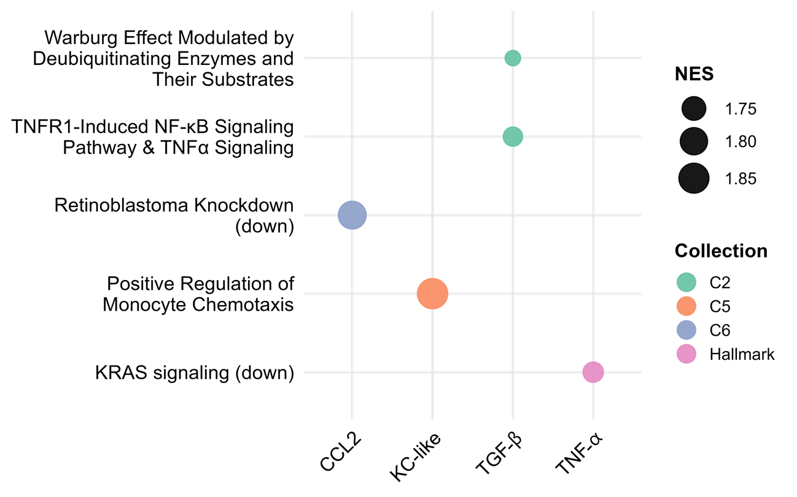
Figure 5: Selected GSEA Pathways across cytokines. Each panel shows one of five pathways (y-axis) across four cytokine comparisons (x-axis). Dot color indicates the MsigDB collection (C2, C5, C6, Hallmark) and dot size is proportional to the normalized enrichment score (NES). Larger dots denote stronger enrichment. Pathway names have been edited for clarity.

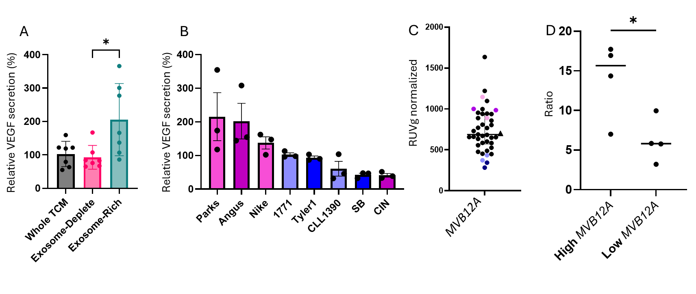
Figure 6: Validation of MVB12A’s role in exosome-associated VEGF stimulation. (A) VEGF secretion by macrophages (% of control) after treatment with unmodified tumor-conditioned media (TCM), exosome-deplete TCM, and exosome-rich media, n=3. (B) VEGF secretion (% of control) from TCM derived from high- versus low-MVB12A cell lines, n=3. (C) RUVg-normalized MVB12A expression across all cell lines. For (B) and (C), colors indicate “high” (purple) and “low” (blue) expressors; darker shades denote the discovery set, lighter shades the validation set. (D) Ratio of presumed exosome-associated to free VEGF in the 7 high- vs. low-MVB12A lines from (A) and (B) (p = 0.032 on a Student t-test).

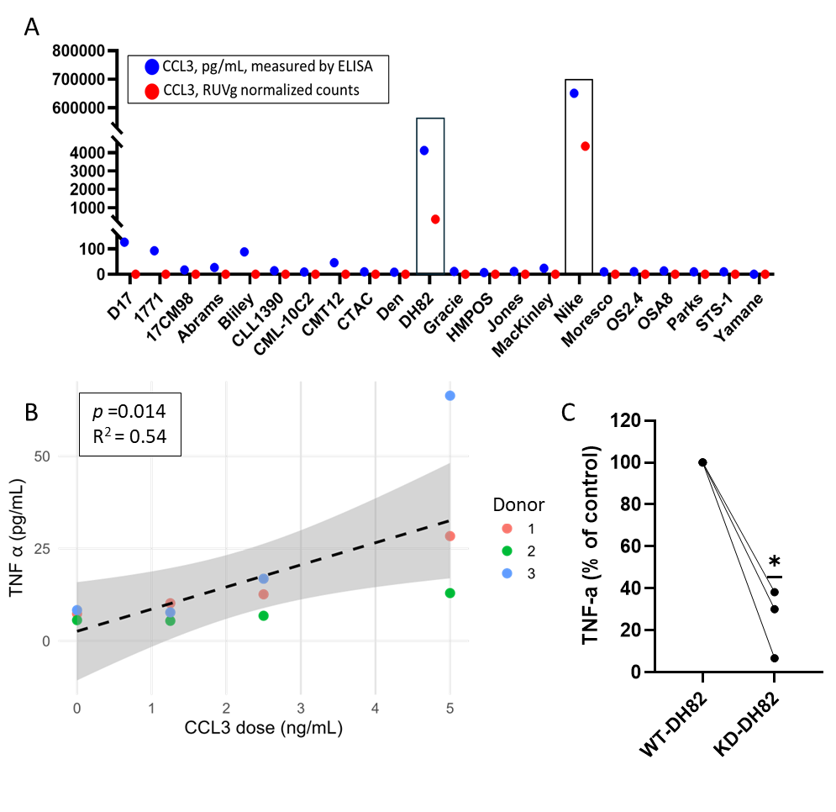
Figure 7: CCL3‐induced TNF-α secretion by macrophages. (A) CCL3 protein (blue) and mRNA (red) levels in tumor-conditioned media from multiple cell lines. DH82 and Nike exhibit the highest transcript and secreted protein, whereas some lines show low protein despite undetectable mRNA. (B) Dose-dependent TNF-α secretion by primary macrophages in response to recombinant CCL3 (0–5 ng/mL), modeled using a donor-nested mixed‐effects regression, n=3. (C) Knockdown of CCL3 in DH82 cells (KD-DH82) prior to TCM collection markedly reduces macrophage TNF-α secretion across three independent donors compared to TCM collected from wildtype (WT)-DH82, n=3.

Supplementary Materials
Supplementary Table 1: Signalment and Monocyte Count of the 3 Donors for Initial TCM Generation. MC = male castrated, MI = male intact, OSA = osteosarcoma, L = low (below reference range)
Breed | Age (yrs) | Sex | Weight (kg) | Diagnosis | Monocyte Count
Mastiff | 8.8 | MC | 74.3 | Periosteal OSA | 0.1 (L)
Great Dane | 1.2 | MI | 52.6 | Metastatic OSA | 0.4
Goldendoodle | 7.1 | MC | 32.7 | Multicentric T cell lymphoma | 0.9

Supplementary Table 2: Effect of cell line count on cytokine secretion. Linear mixed‐effects model results for the association between cell count (per million) and cytokine secretion (pg/mL), with donor as a random intercept. Estimates are slopes ± SE and p-values; no significant effects were observed.
Cytokine | Estimate | Std. Error | p-value
VEGF | 31.788 | 43.275 | 0.465
IL-8 | 244.18 | 276.38 | 0.380
KC-like | -0.1550 | 5.1374 | 0.976
IL-10 | -45.139 | 88.116 | 0.610
CCL2 | 1237.8 | 1335.7 | 0.357
TNF-α | -3.4722 | 5.2546 | 0.511
TGF-β | -1.8084 | 1.0005 | 0.075

Supplementary Table 3: Top and bottom quartiles used for DEG analysis.
Cytokine | Top Stimulators | Bottom Stimulators | Test Used | p-value
VEGF | Jones  Nike  OS2.4  Moresco  OSA8  STSA-1 | Bliley  D17  17CM98  CML-10C2  CLL1390  1771 | Student’s  t-test | <0.0001
IL-8 | Abrams  CML-6M  CMT12  D17  Nike  Parks | Moresco  STSA-1  OSA8  Yamane  OS2.4  1771 | Mann-Whitney | 0.0022
KC-like | Abrams  D17  17CM98  Gracie  Parks  1771 | CTAC  MacKinley  CLL1390  Yamane  Moresco  STSA-1 | Student’s  t-test | 0.0006
IL-10 | Nike  OSA8  CML-6M  CMT12  Abrams  DH82 | 1771  MacKinley  CTAC  CLL1390  Jones  OS2.4 | Mann-Whitney | 0.0022
CCL2 | HMPOS  OS2.4  DEN  Parks  Bliley  Moresco | 17CM98  D17  Nike  MacKinley  Yamane  1771 | Student’s  t-test | <0.0001
TNF-α | OSA8  Nike  CMT12  DH82  CML-6M  Abrams | Moresco  D17  Jones  OS2.4  CTAC  CLL1390 | Welch’s  t-test | 0.0016
TGF-β | Jones  CML-6M  HMPOS  OS2.4  CML-10C2  CMT12 | Parks  D17  CLL1390  1771  Yamane  17CM98 | Welch’s  t-test | 0.0018
TGF-β:  CCL2 | Nike  Bliley  Abrams  Jones  CLL1390  CML-10C2 | 1771  OS2.4  Parks  CTAC  HMPOS  STSA-1 | Mann-Whitney | 0.0022

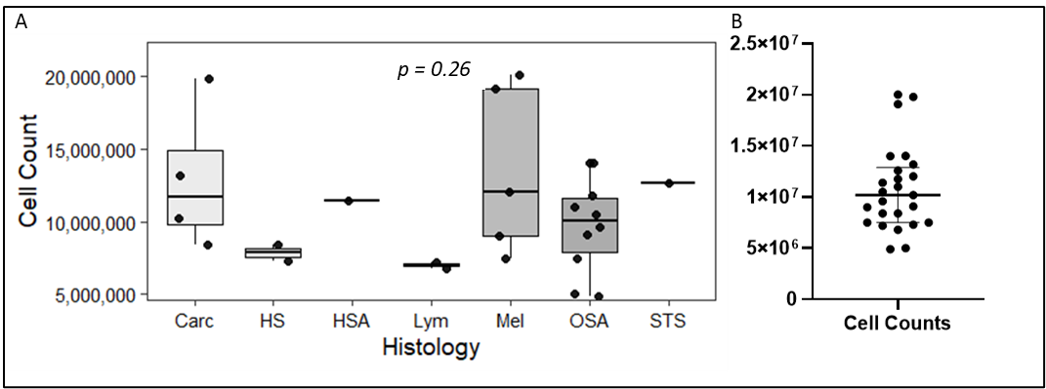
Supplementary Figure 1: Cell count by cell line histology. (A) Distribution of cell counts by histology. Carcinomas of distinct origins (mammary, thyroid and urothelial) were grouped together for analysis. Kruskal-Wallis rank sum test (chi-squared = 7.7166, df = 6, p-value = 0.2596). (B) Median +/- interquartile range of cell counts at time of TCM harvest. Carc = carcinoma, HS = histiocytic sarcoma, HSA = hemangiosarcoma, Lym = lymphoma/leukemia, Mel = melanoma, OSA = osteosarcoma, STS = soft tissue sarcoma.

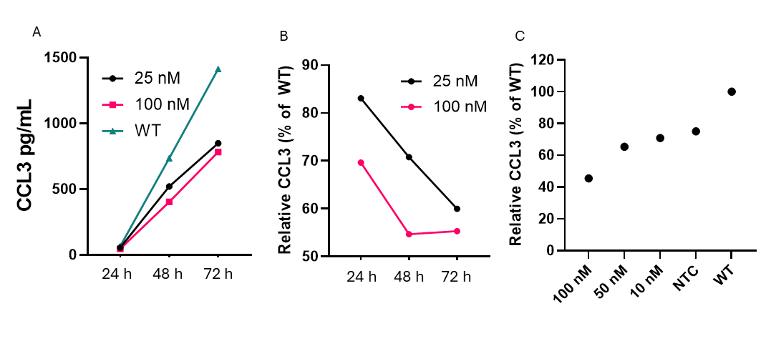
Supplementary Figure 2: CCL3 knockdown of DH82. (A) Absolute CCL3 values measured by ELISA in supernatants of wildtype (WT) DH82, along with DH82 treated with 25 or 100 nM siRNA. (B) Same data, showing relative CCL3 normalized to WT. X-axis for (A) and (B) is time in hours post-knockdown. (C) Densiometric quantification of western blot bands normalized to WT DH82 cells treated with either with NTC (non-targeting control siRNA) or various concentrations of CD206-targeted siRNA. Lysates collected at 72 hrs.

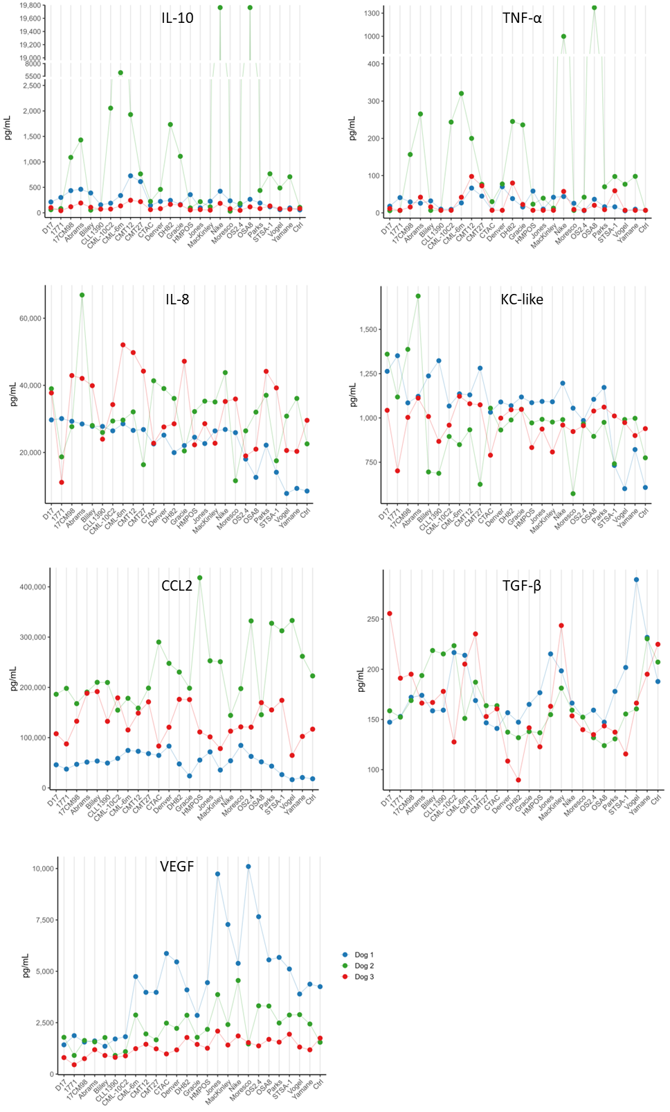
Supplementary Figure 3: Raw values for each analyte, color-coded by donor.

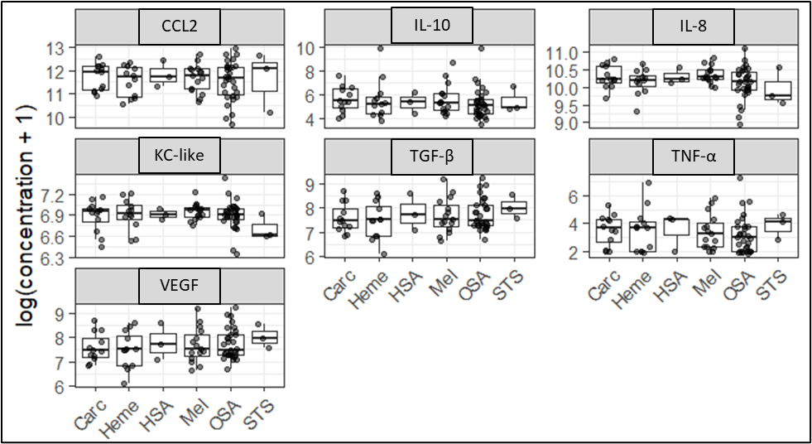
Supplementary Figure 4: Impact of histology on cytokine secretion. No significant differences were noted in cytokine production based on histology. All p-values >0.05 based on Benjamini Hochberg-adjusted linear mixed model and Kruskal-Wallis non-parametric test. Carc = carcinoma, Heme = hematopoietic (histiocytic sarcoma and lymphoma/leukemia), HSA = hemangiosarcoma, Mel = melanoma, OSA = osteosarcoma, STS = soft tissue sarcoma.

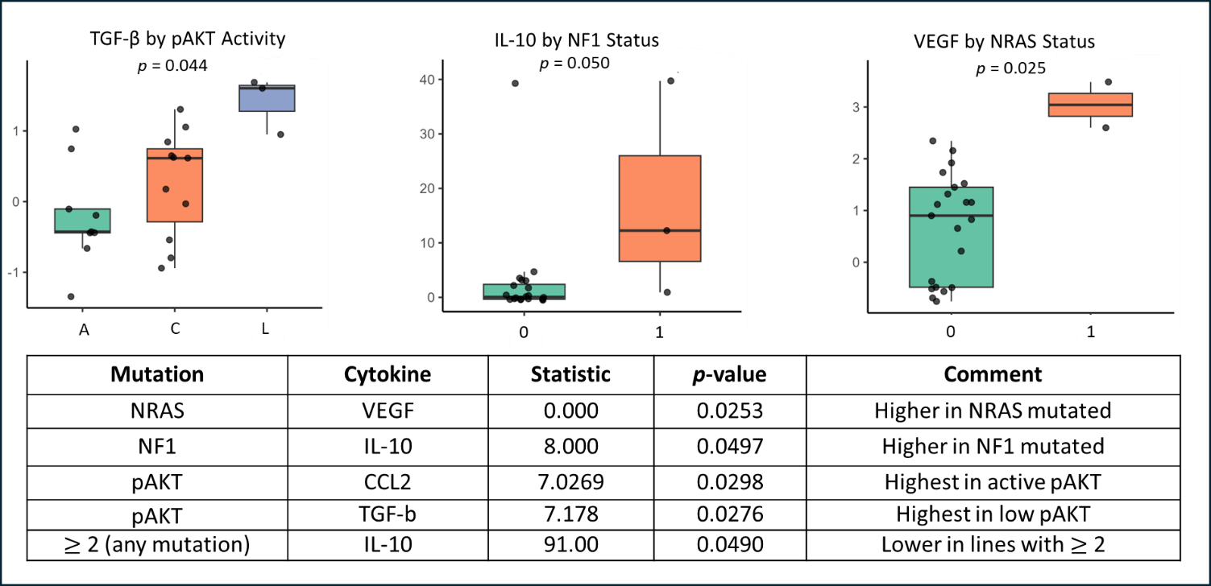
Supplementary Figure 5: Exploratory findings of cytokine secretion by mutation and phosphorylation status. Boxplots show the distribution of modified Z-scores of cytokine secretion for three mutation or phosphorylation–cytokine pairs with unadjusted p < 0.05. For the three‐level pAKT factor (A = active, C = constitutive, L = low/phosphorylation), differences were assessed by Kruskal–Wallis tests; for binary mutations (0 = wild-type, 1 = mutant), by Wilcoxon rank-sum tests. Additional examples are included in the table. Unadjusted p-values are displayed and should be interpreted as hypothesis-generating only. Mutation and phosphorylation data taken from [44]

